Veterinary Referral for Behaviour Modification
Why is referral necessary? Behaviour problems may arise both directly and indirectly because of concurrent or previous medical problems. Before commencing behaviour modification work it is important for the animal’s vet to first rule out / treat any organic causes of the problem and to prioritise the diagnostic and treatment strategy to be used in any given case. Veterinary referral is therefore necessary for Julie T Daniels of Thinking Paws Ltd (credentials below) to commence behaviour therapy with any dog or cat. It is also a mandatory requirement for maintaining membership of professional bodies advocating the highest standards of animal welfare. Further details can be found here: https://www.capbt.org/ https://fabclinicians.org

To safeguard the welfare of your patient and to indicate your approval for Julie T Daniels of Thinking Paws Ltd to undertake behaviour therapy, please complete the following:

Client details
Client’s name:
Pet’s name:
Species / breed:

Veterinary surgeon details

Veterinary surgeon name:
Practice address & postcode:
Telephone:
E:mail:
Brief description of behaviour problem (if known):

Please delete as appropriate:
The above client has provided consent to you directly (or in forwarding this form to you) for the disclosure of clinical information regarding their pet for the purposes of behaviour therapy: Yes / No
The patient’s medical history accompanies this form / will be supplied separately by E:mail

Veterinary surgeon (MRCVS) signature: Date:

Julie T Daniels BSc (Hons), PhD, DipCABT, MSc (Clinical Animal Behaviour)

Director, Thinking Paws Ltd Reg 13469472
Pre-certification (awaiting final assessment for ‘Certificated Clinical Animal Behaviourist): Association for the Study of Animal Behaviour
Candidate Member: Fellowship of Animal Behaviour Clinicians
Certified Animal Behaviourist and Trainer: COAPE Association of Applied Pet Behaviourists and Trainers
Full Member: Association of Pet Dog Trainers
Registered Animal Training Instructor: Animal Behaviour and Training Council

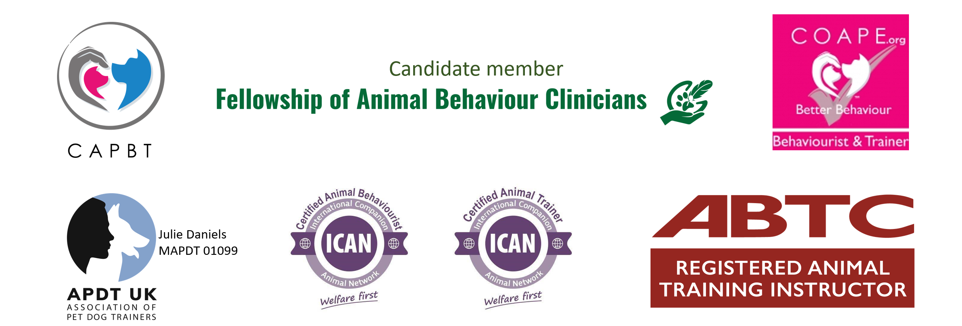
Thinking Paws Ltd Registered Company Number 13469472
07817 210109 - juliedaniels@thinkingpaws.co.uk - www.thinkingpaws.co.uk

